Statutory Change Alert

Namibia – Increase in Social Security Contribution Ceiling – 1st September 2026


NAMIBIA

We help you achieve your global ambitions

Thank you for trusting Mercans to outsource your HR and Payroll functions. We propose HR consulting services, actionable solutions, and cost-effective global payroll processing tools to energize your human capital management in real-time and augment your performance. We are dedicated to becoming your business growth facilitator.

 | Global Payroll Solutions – Boost your HR brand and employee satisfaction  Rationalize your HR budgets, monitor your data, and optimize your global payroll tasks in real-time. Systematize processes and streamline HRM lifecycles with HR Blizz™, our unified SaaS platform, to ensure your employees are paid accurately and on time.
 | PEO/GEO Services – Easily hire, deploy and manage your workforce abroad  A reliable Professional Employer Organization (PEO), Mercans is your trusted employer of record to globally select, engage, and manage highly qualified personnel on your behalf, through integrated Global Employment Outsourcing (GEO).
 | Global Talent Acquisition – Quickly fill vacancies with only the best candidates  Mercans supports you in designing/deploying long-term HR strategies and processing full-cycle recruitment. Our ATS Suite Mesaar™ and our hiring experts help to screen, select, attract the right candidates for your organization and populate your pipeline of prequalified talents.
 | BPO Services – Reclaim the focus on your core activities to expand your business  Concentrate on the essentials: outsource non-primary activities and your front- and back-office functions to Mercans. Save the time, money, and energy needed to refine the value chain engagement of your customers and suppliers and increase revenue.
 | HR Management SaaS – Access customizable cloud-based online platforms  Centralize your HR function on an all-in-one user-friendly and self-service platform. Combined with the expertise of our consultants, the Mesaar SaaS offers a built-in applicant tracking system and easy-integration features to improve internal processes.
 | Local Statutory Compliance – Forget the hassle of setting up branches abroad  Mercans seasoned HR advisory team are compliance experts specialized in local cultures, business protocols, and tax and legal specificities. They are committed to ensure quick go-to-market abroad and achieve a compliant global expansion, risk-free from A to Z.

Mercans at a Glance

160+  Countries | 20  Years of Success | 1K+  Payroll and HR Specialists
22k+  Clients Worldwide | 97%  Client Retention Rate | 1.5X  Annual Revenue Growth
95k+  Largest Single Country Payroll | 25M+  Pay Slips per Annum | 0  Security Breaches

Number one for outsourced payroll services, we are endorsed by international authorities.

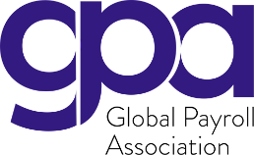 |  | 


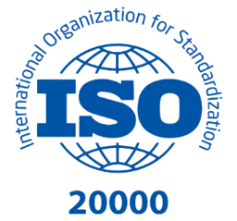
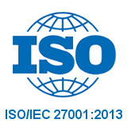
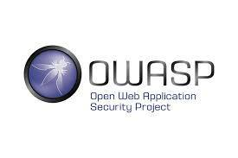
Mercans has the highest industry quality and IT security certificate certificate

Namibia - Increase in Social Security Contribution Ceiling - 1st September 2026

Social Security contribution ceiling (Maternity Leave, Sick Leave and Death Benefit Fund)

Namibia has raised the maximum monthly basic wage on which Social Security Commission (SSC) contributions to the Maternity Leave, Sick Leave and Death Benefit Fund are calculated, from NAD 11,000 to NAD 12,500. The change was made by Government Notice No. 236 of 2026 (Government Gazette No. 8975 of 15 July 2026), which amends regulation 1 of the regulations published under Government Notice No. 198 of 1995, under section 47 of the Social Security Act, 1994 (Act No. 34 of 1994). The Gazette states an effective date of 1st March 2026; the SSC has informed employers that, due to the delayed gazetting, the new ceiling applies from 1st September 2026. The same notice also fixes the next ceilings: NAD 14,000 from 1st March 2027, NAD 15,000 from 1st March 2028 and NAD 16,000 from 1st March 2029.
The before and after comparison is set out below:
Item | Up to 31 Aug 2026 | From 1 Sep 2026 | Change
Maximum monthly basic wage (ceiling) | NAD 11,000 | NAD 12,500 | Ceiling up
Maximum employee contribution (0.9%) | NAD 99.00 | NAD 112.50 | Maximum +13.50
Maximum employer contribution (0.9%) | NAD 99.00 | NAD 112.50 | Maximum +13.50
Contribution rates (employee / employer) | 0.9% / 0.9% | 0.9% / 0.9% | No change

Payroll impact
Higher SSC employee deductions and employer contributions for every employee earning more than NAD 11,000 a month, from the September 2026 pay run (maximum NAD 112.50 each side). The ceiling rises again to NAD 14,000 from the March 2027 pay run. PAYE is not affected, as SSC contributions are not deductible.

Official sources: Government Gazette No. 8975, Government Notice No. 236 of 2026 (lac.org.na/laws/2026/8975.pdf)

Please contact your Mercans’ services delivery team for any additional information regarding the implications of the above change.

They already trust Mercans

 |  | 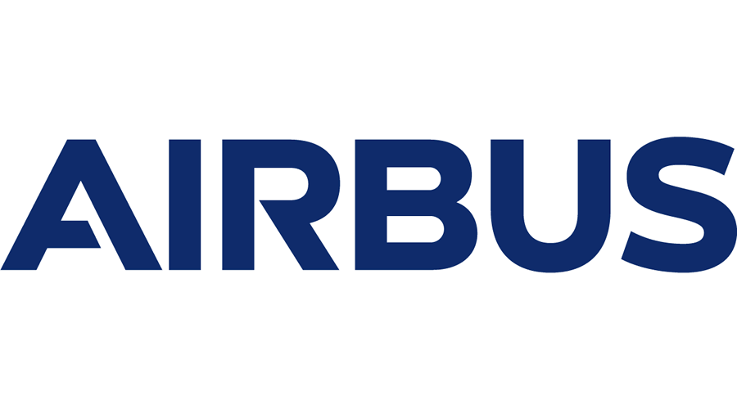 |  | 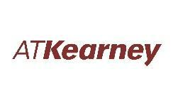
 | 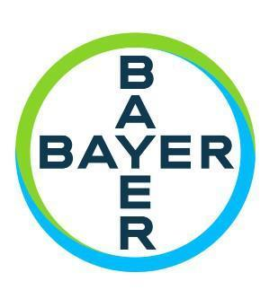 |  |  | 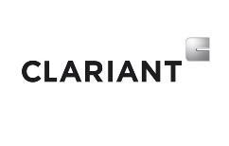
 |  |  |  | 
 |  |  | 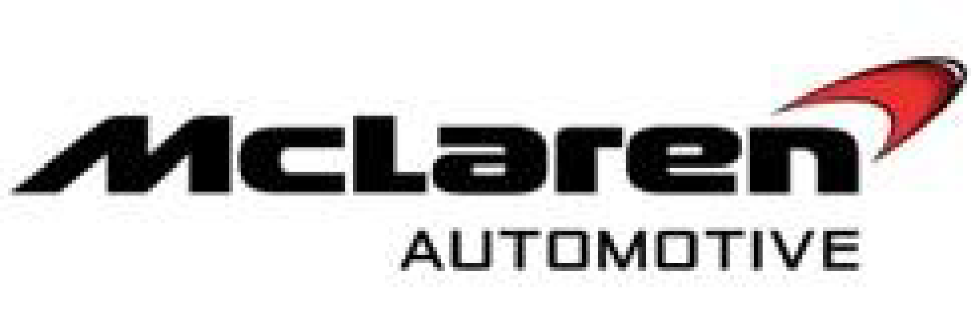 | 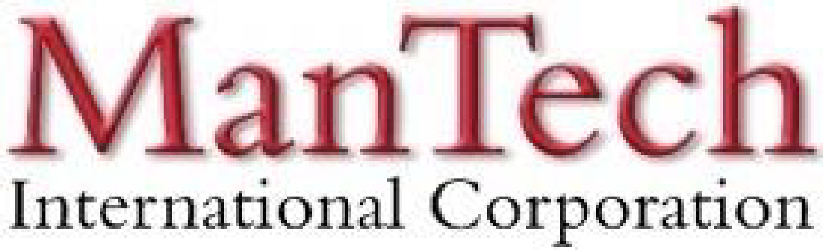
 | 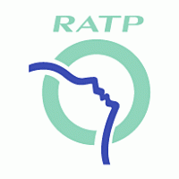 |  |  | 

What Makes Mercans your HR and Payroll Partner of Choice?

We Simplify Employment Tasks Worldwide

Everywhere for Everyone
We are a borderless people engagement enabler, driven by technology and innovation. We deliver bespoke human capital management services and global payroll solutions to empower businesses across 110+ countries regardless of their organizations’ size and their industry. We pride ourselves on being global people experts with a striking local presence, committed to making your teams happy, and ensuring the consistent and sustainable growth of your organization.

Local Presence. Regional Strategy. Global Success
Supported by 500+ payroll and HR specialists with in-depth local knowledge, Mercans operate globally. Our pioneering human resources consulting services and trailblazing SaaS platforms are already satisfying 5,000+ international clients, ensuring timely measurable results and bottom-line savings. Thanks to success-oriented teams striving for excellence and taking care of our clients’ tasks within budget, we have gained the trust of major multinational companies.

A Revolutionary Service Delivery System
Say goodbye to third-party service providers, offshore call centers, fragmented data, and endless chains of sub-contracts.

Mercans cloud-based SaaS Products, HR Blizz™ & Mesaar™, combine the performance of proprietary technologies with a human touch. Cost-effective, they are fully-compliant self-service tools, packed with smart built-in features for your peace of mind. All your data are integrated into single interfaces accessible from everywhere and on any device.

Trailblazing Cloud-Based SaaS Products
HR Blizz & Mesaar, our Software-as-a-Service platforms, both propose a preconfigured API integration capability with all the major global HRMS platforms, including SuccessFactors, Workday, Oracle HCM, and MS Dynamics. All Mercans systems and processes are GDPR compliant, ISO 9001, 20000, 27001 certified, and SOC 1 and SOC 2 audited. A registered Finpro expert, Mercans is also a member of the Global Payroll Association and the Global Payroll Management Institute.

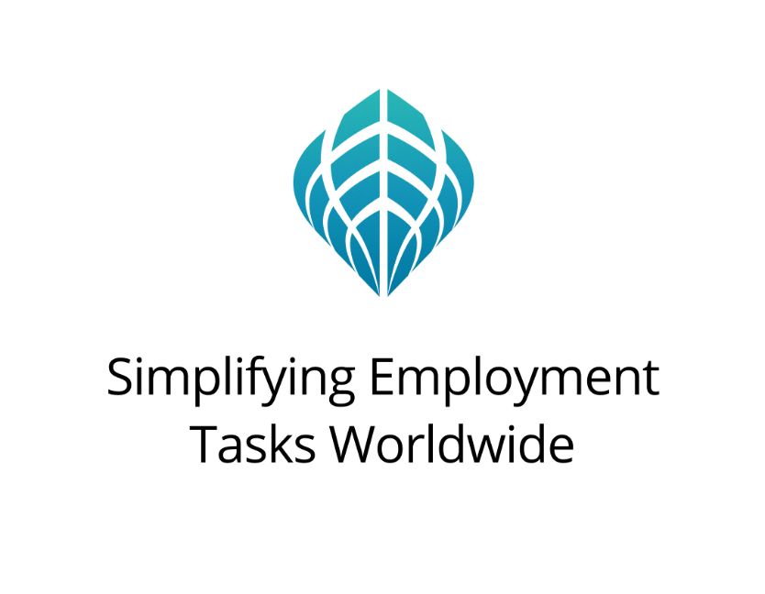

+1 877 MERCANS (637 2267) | Toll-Free
Europe: +44 20 328 777 62
Americas: +1 646 798 5541
Middle East: +971 43 999 260
Asia: +81 50 5539 5354
info@mercans.com | mercans.com

© 2026 Mercans LLC

